Project-01

3TIER ARCHITECTURE

NAME: B.PAVANI

MBL : 7569217017

BATCH: 119[7AM]

GMAIL: [bingipavani343@gmail.com](mailto:bingipavani343@gmail.com)

* Create a VPC in region Mumbai. Create one public subnet & two private subnets in one of the availability zone. One public subnet & two private subnets in another availability zone. attach internet gateway to the public route & NAT gateway for the private routes. Associate the respective subnets to their respective routes.

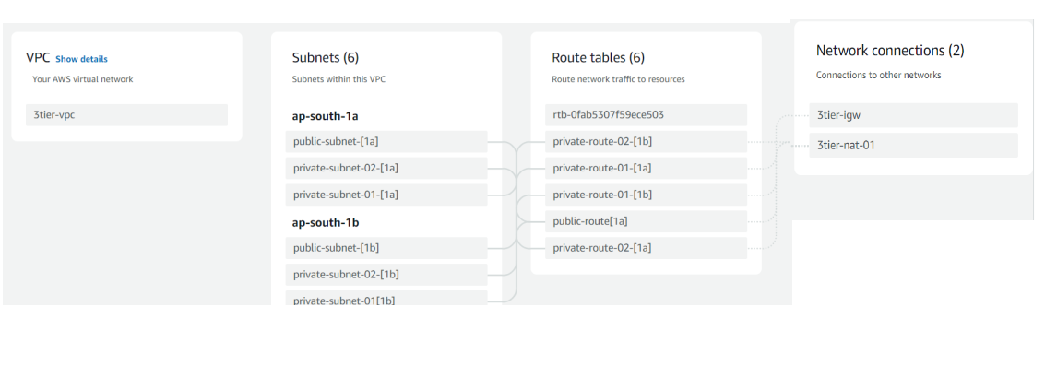

* goto routes select the public route make it as the main route table. Goto subnets>>action>>edit subnet settings>>auto assign public ipv4 address>>save. 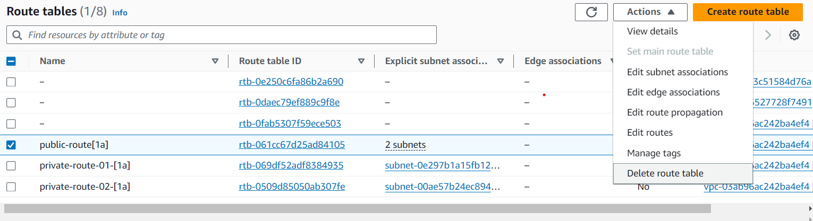

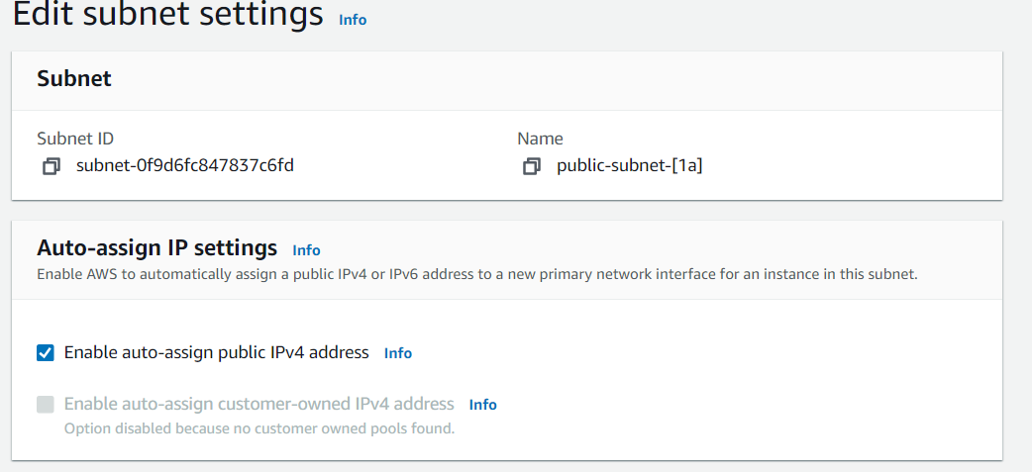

WEB TIER

* goto launch template in EC2 create a template with name ‘3tier-template’. Create the template with following provisions:

amazon linux>>t2 micro>>keypair. 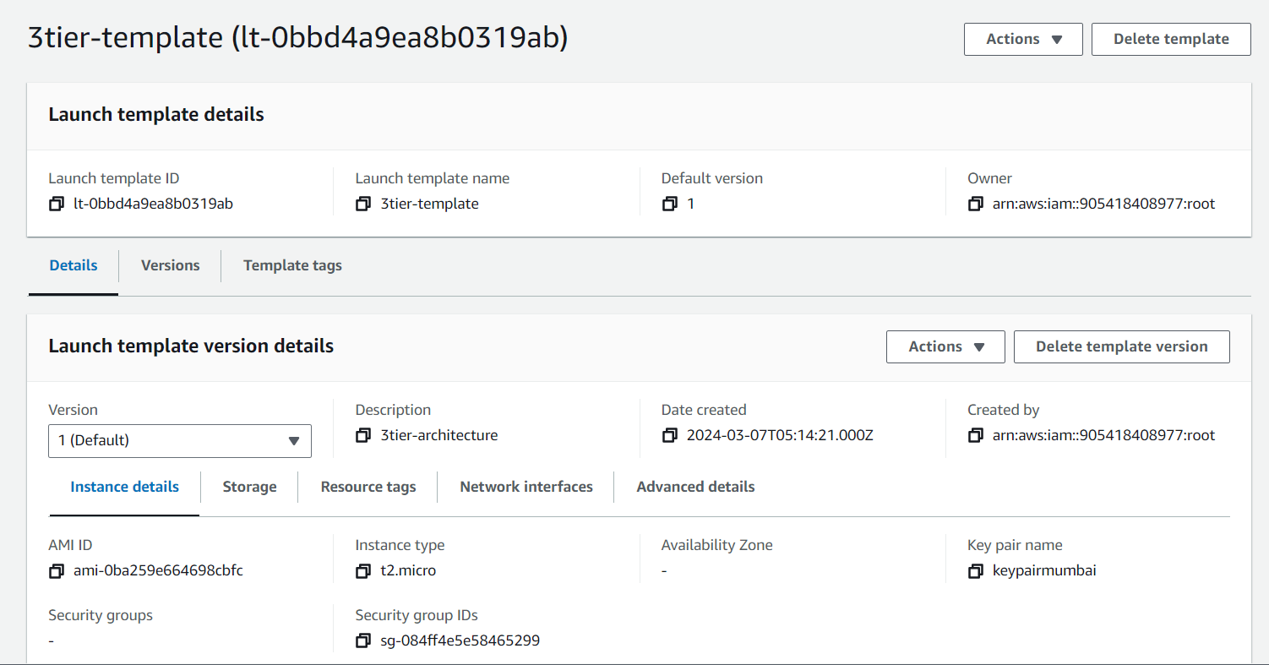

.

* Without specifying the subnets proceed with create new security group add the inbound rules with ssh and HTTP rules. 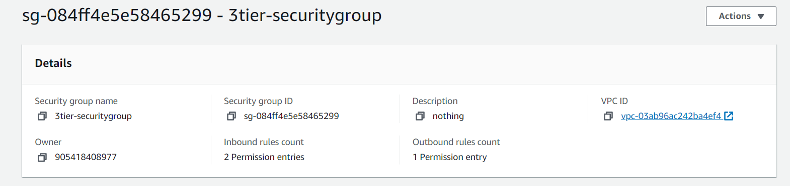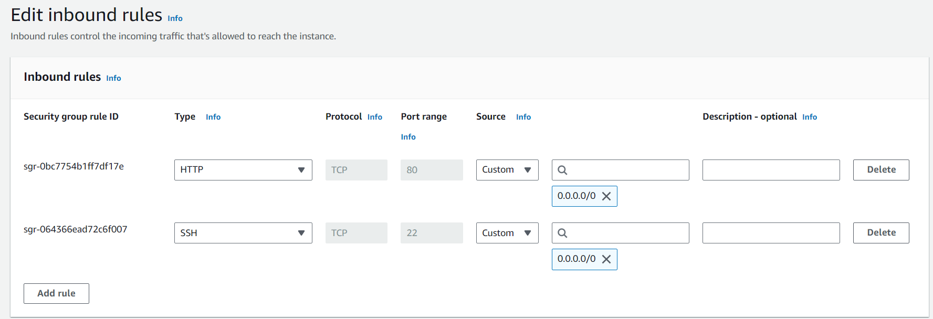
* Create a autoscaling group. Navigate to autoscaling group and create new group add the template which is created in previous step i.e ‘3tier-template’. Select the respective VPC and two public subnets of the VPC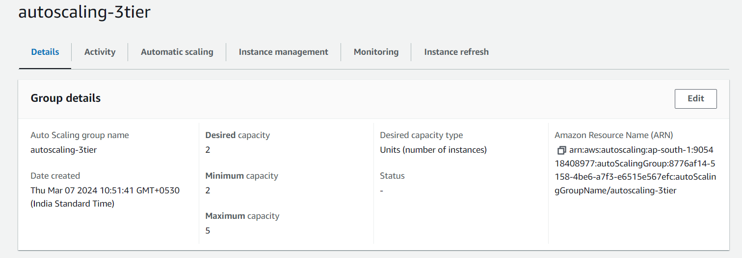
* Create a application load balancer>>name the load balancer>>internet facing>>listeners and routing>>port 80>>create a target group>>add the target group. 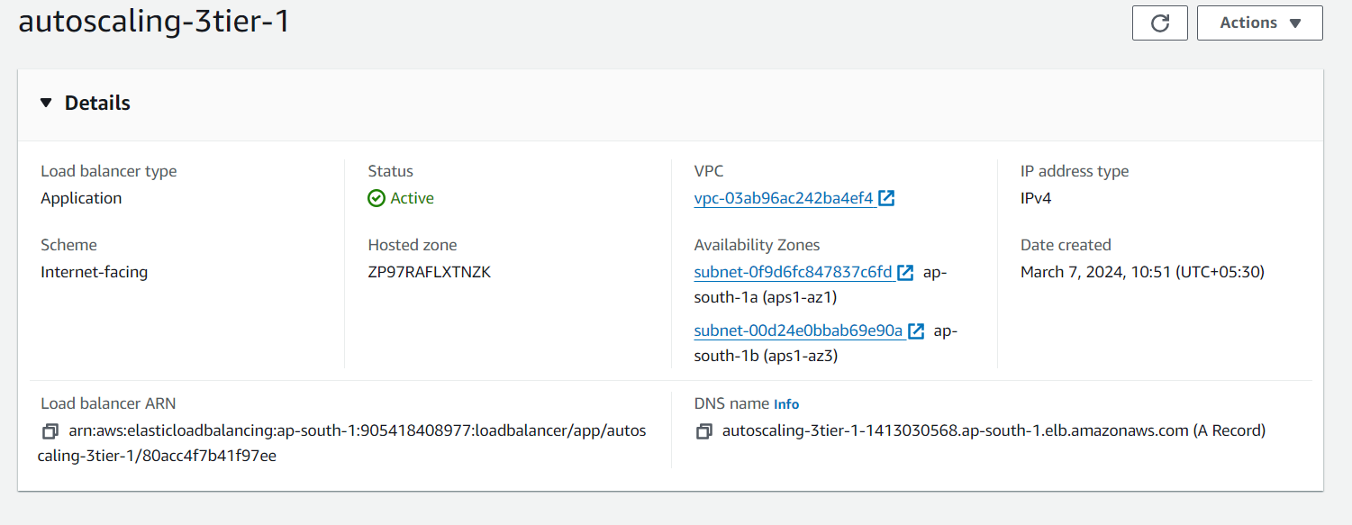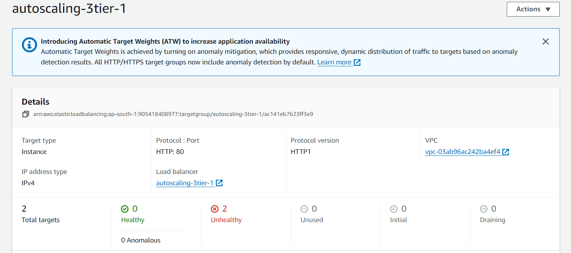
* Lets connect to the ssh EC2. 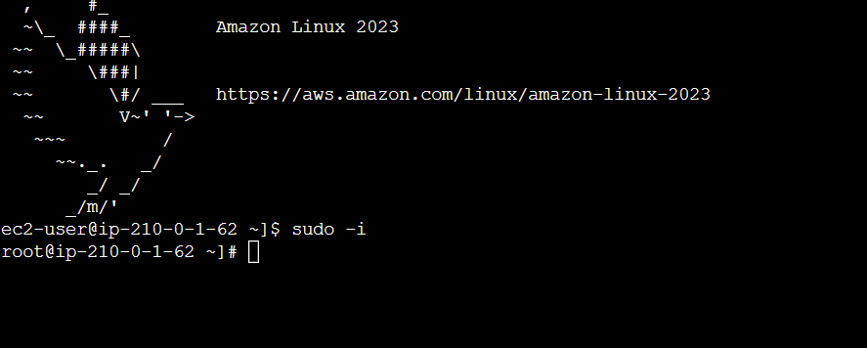

APPLICATION TIER

* Launch a new template. Name the template>>amazon linux>>t2 micro. 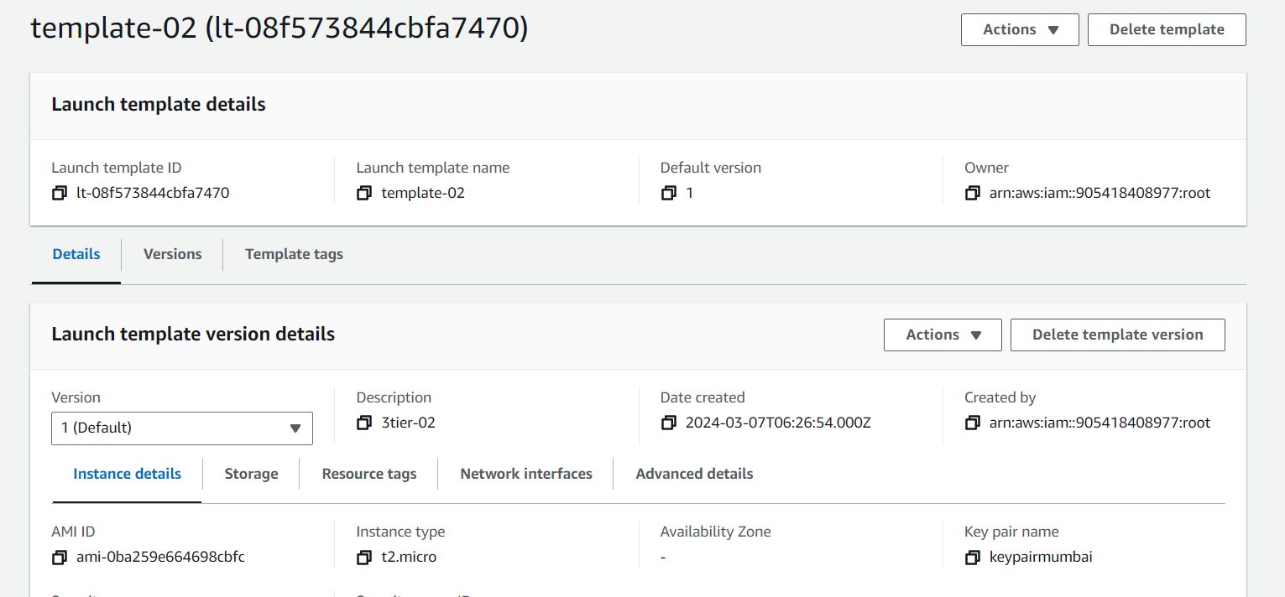
* Create a new security group with ssh and HTTP inbound rules. 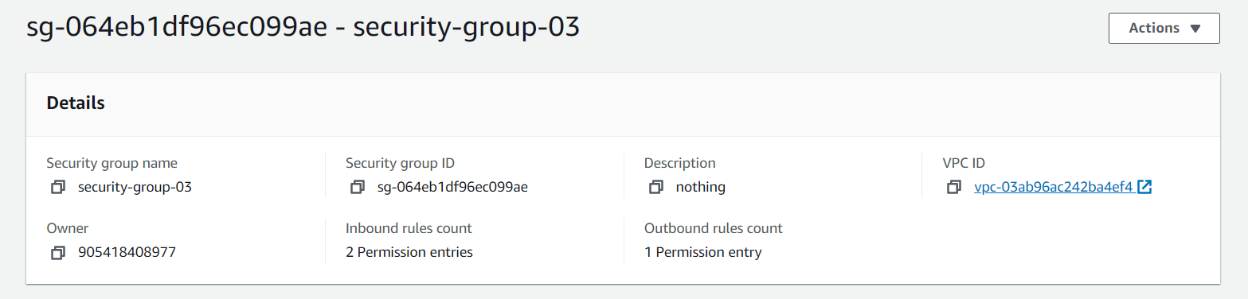 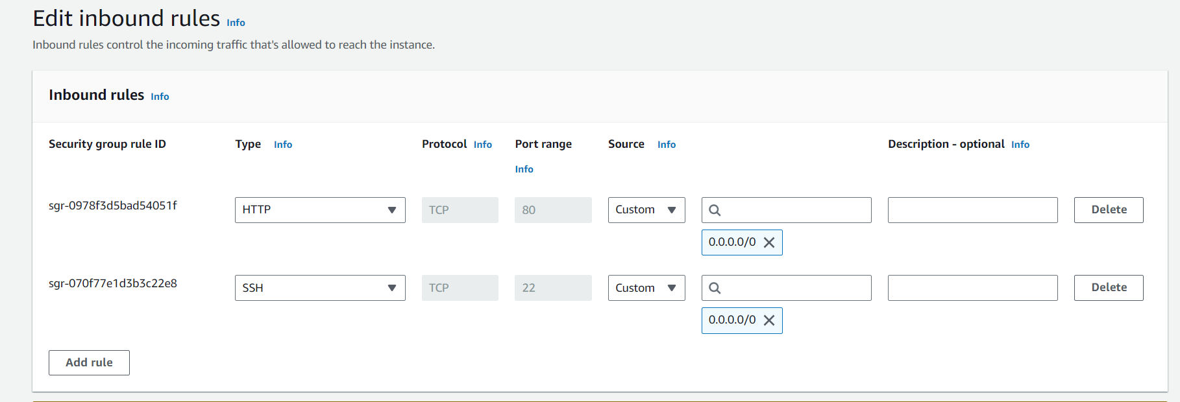
* Create a autoscaling group. Navigate to autoscaling group and create new group add the template which is created in previous step. Select the respective VPC and two private subnets of the VPC. 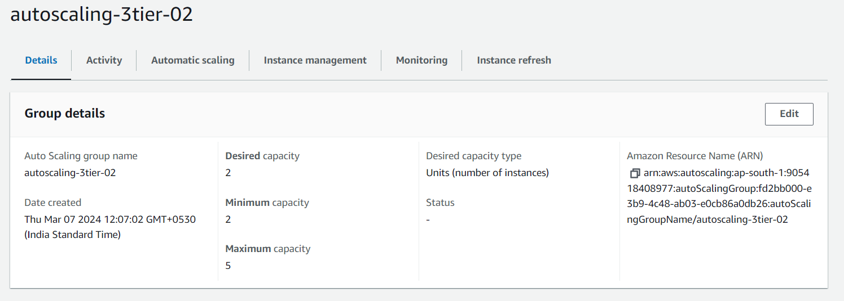
* Create a application load balancer>>name the load balancer>>internet facing>>listeners and routing>>port 80>>create a target group>>add the target group.

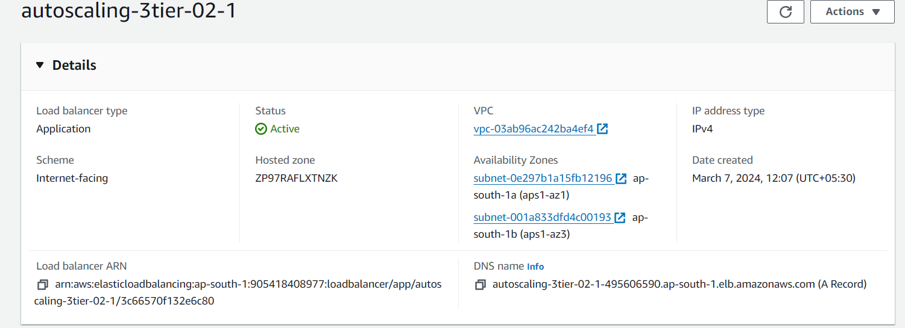

* More two instances has been created.
* The connection is established in private via public. 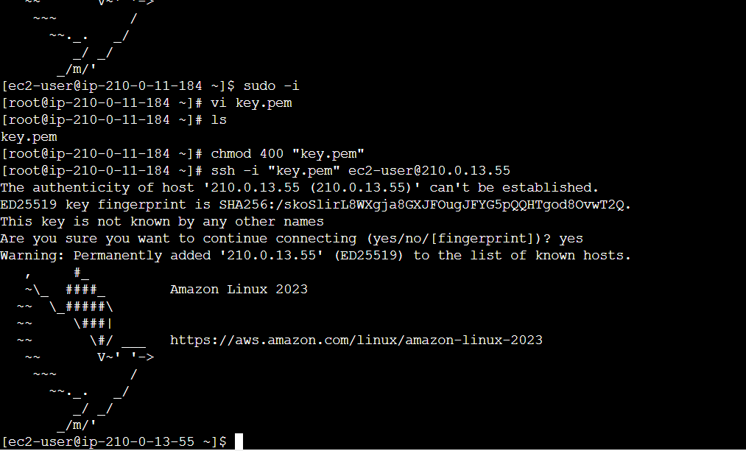

DATABASE TIER

* Create a security groups and add inbound & outbound rules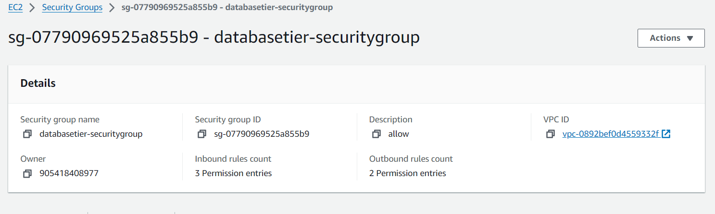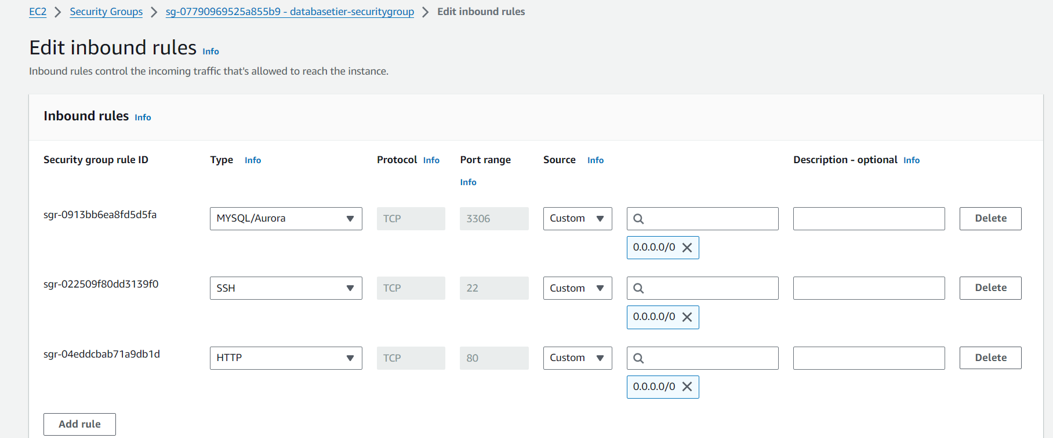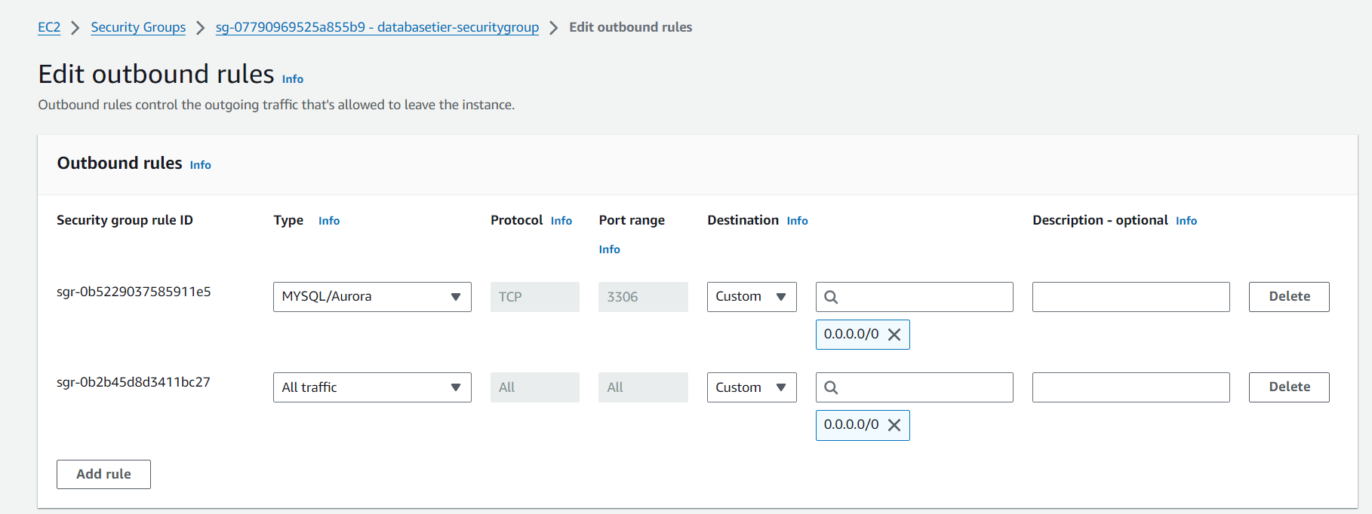
* Create database subnet group and associate them with VPC & two private subnets. 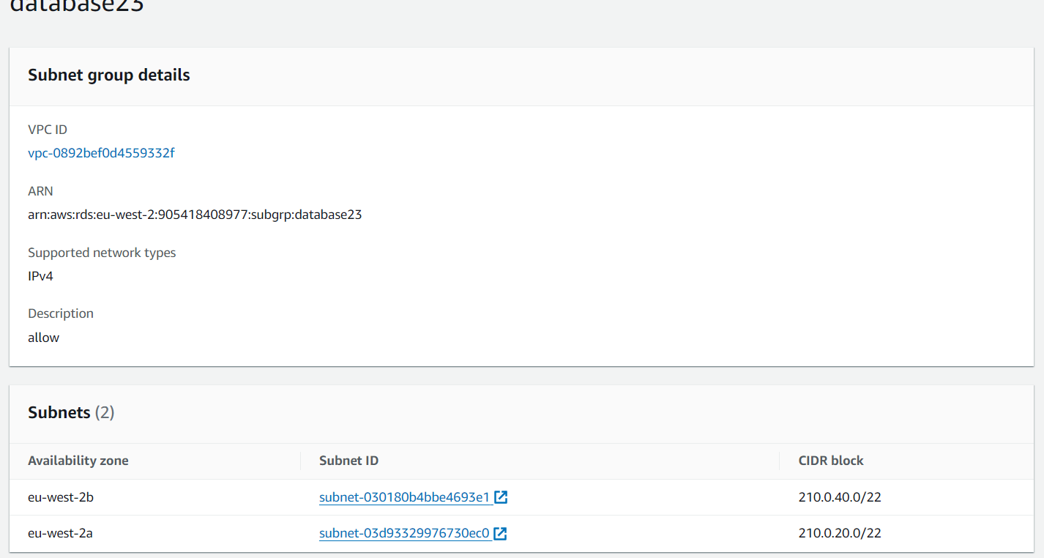
* Create a Relational database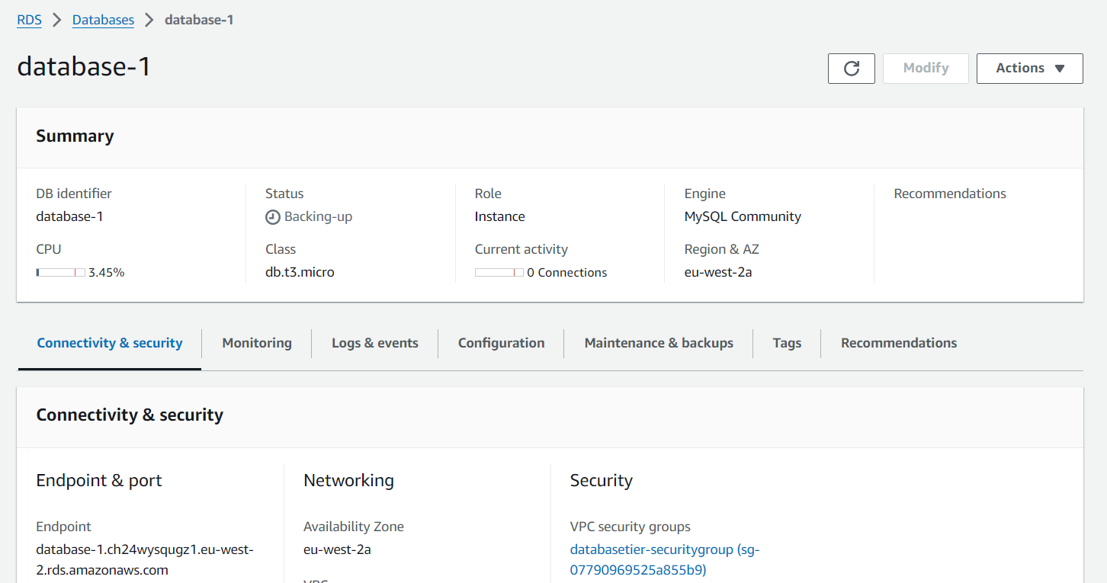
* Now lets lanuch an instance and check the connectivity to data endpoint of a mysql database